
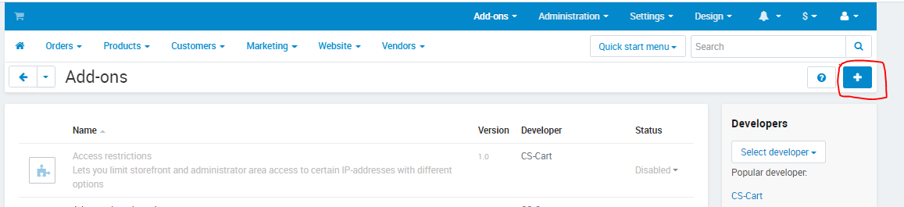
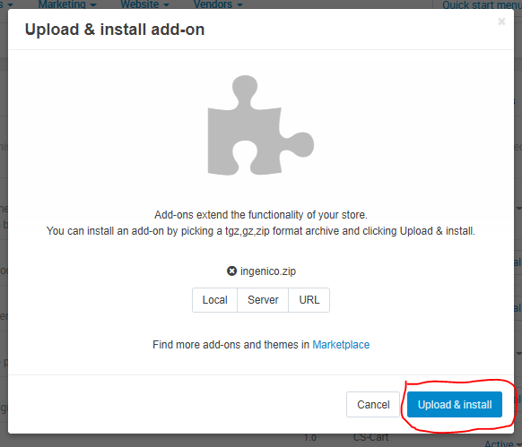
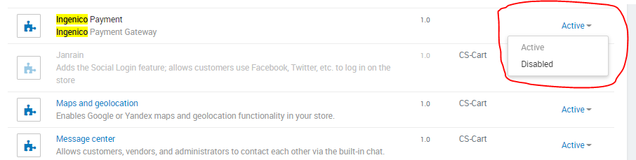
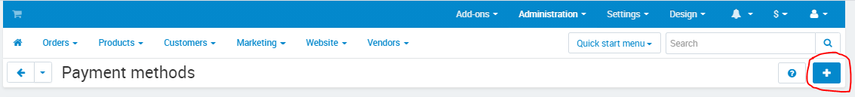
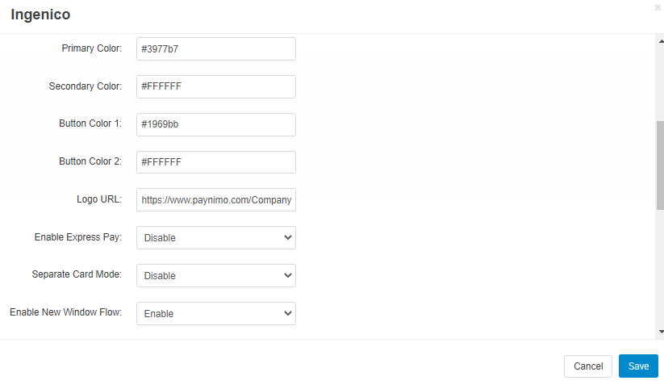
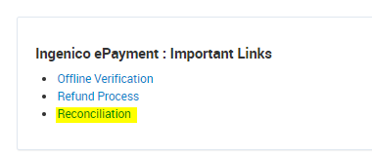
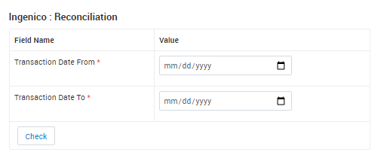
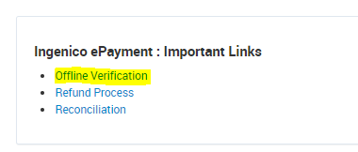
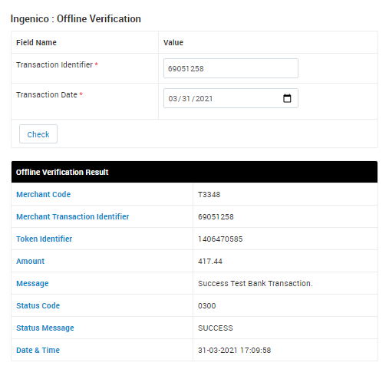
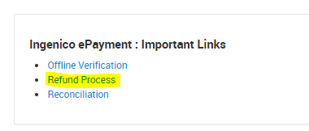
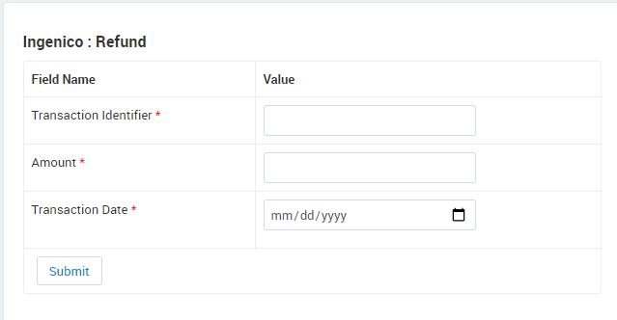


INSTALLATION MANUAL

Table of Contents

Applicable Version………………..…....……………………………….……………………….1

Installation....………………………….……….……………………………………………………1

Configuring worldline………………..……………………………………………………………3

Applicable versions

Applications | Versions
PHP | 7.3.x
cs-cart | 4.12.x

Installation

Please follow the given steps to install and run the worldline Payment Gateway module

1. Download the worldline folders and create the zip file or directly download the zip file.
2. Go to Add-ons->Manage add-ons->click on ‘+’ icon on top right corner.
3. Select the zip file which you created or downloaded and click on the upload & install button.
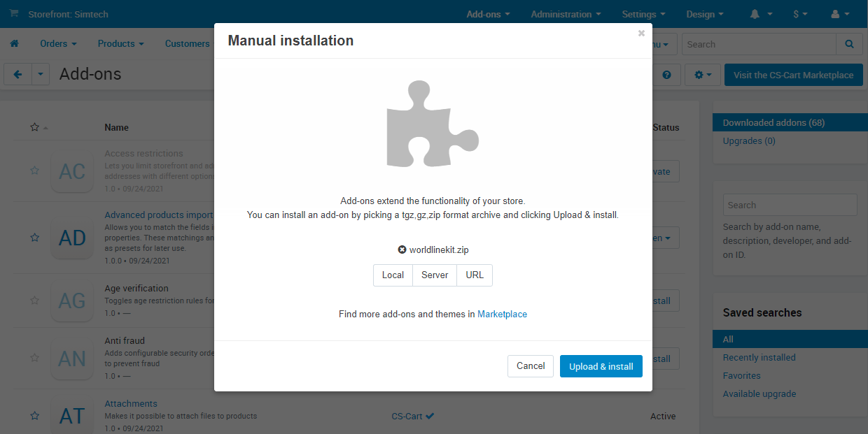
4. After successful installation you can see the ‘worldline Payment’ in the addons list, you need to activate it using the dropdown icon on the right side.

Configuration
- To configure this payment method click go to administration->Payment Methods and then click on the ‘+’ icon.
- Setup it as below :
General :
Column Name | Description
Name | worldline
Processor | worldline
Icon | you can select the worldline icon given with the kit.
Configure :
Column Name | Description
Merchant ID | Enter Merchant Code
Merchant Scheme Code | Enter Scheme Code
Salt | Enter Salt.
Payment Type | For Test mode Select ‘Test’ and for Live mode select ‘Live’
Currency | Select the Currency

Click on the create button and worldline Payment Gateway is now configured & ready to use.

Advanced Configuration
There are also some advanced configuration options you may consider as shown below:

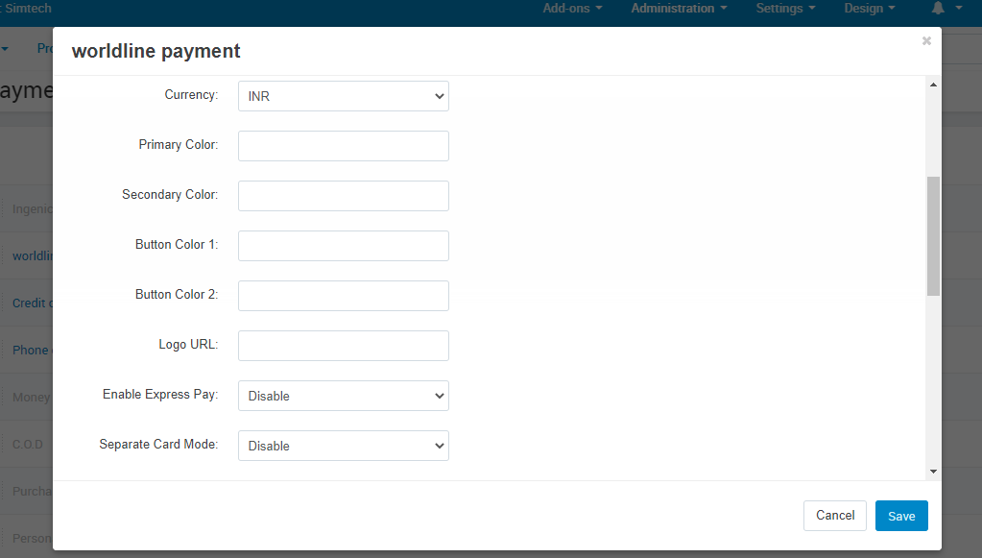
Features List

Dual verification of response
We are validating responses with a hash value and call again Payment Gateway for dual verification from the payment gateway before updating to the order status.

Reconciliation
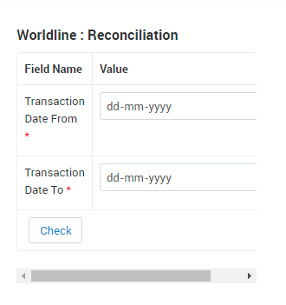
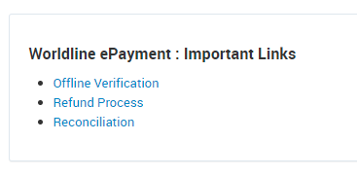
Merchants can update the pending status of the order automatically if the payments are successful. The page link can be found on Admin Dashboard under worldline Payment : Important Links->Reconciliation

S2S Verification
If we do not receive any response from the payment gateway then after 30 mins, we will get a response from the server and based on the response it will update order status.
To configure S2S URL, contact prod team.

S2S url example: http://example.com/admin.php?dispatch=worldline.s2s&action=s2sverification&msg=

MCG
It supports the multi currency like USD, GBP, SGD and a lot more.

Offline Verification

Merchants can verify the status of their payment by using the Payment Verification page. The page link can be found on Admin Dashboard under worldline Payment : Important Links->Offline Verification

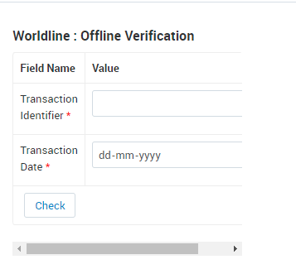

Refund
Merchants should be able to process the refund online for the order whose payment has been done via worldline.
To refund an order, page link can be found on Admin Dashboard under worldline Payment : Important Links->Refund Process

Embed Payment Gateway

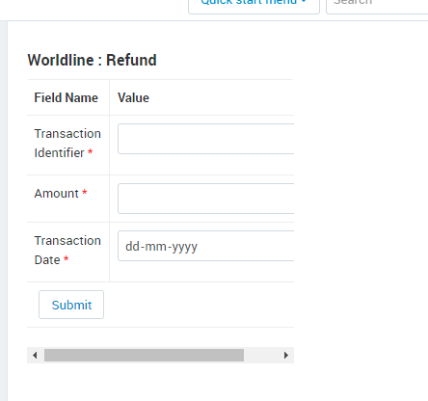

After enabling this setting, payment gateway displays like embedded on the page instead of pop-up so user experience would be good.

Documentation link
https://www.tecprocesssolution.com/proto/p2m/client/salt-based-documentation.htm#online

